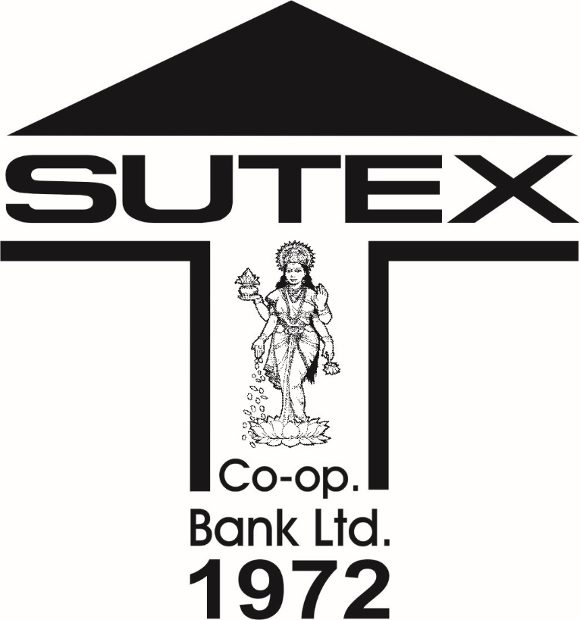

The Sutex Co-operative Bank Ltd.

Customer Service Policy

REVIEWED FOR 2025-26

B.O.D. MEETING DATED – 04/04/2025

Resolution No. 29

Customer Service Policy

OBJECTIVE

The objective of the Customer Service Policy is to set out our Commitment to all categories of our customers availing of our various products and services across all our Branches, Departments and Offices.

VISION

Our total commitment to integrity, ethics, meritocracy, transparency and abiding concern for customers are at the heart of The Sutex Co-operative Bank's value system.

MISSION

To be a people's banker from their bottom of heart with the help of transparent management.

APPLICABILITY OF THE CUSTOMER SERVICE POLICY

- Disclaimer:

The Policy is not a legal document and does not intend to create any new rights or obligations either on the part of the Bank or on the part of the customer.
This Policy is framed as per the guidelines issued by RBI from time to time and applies to all products and services provided by the Bank.

Regulatory/Statutory Compliance

In order to comply with regulatory/statutory requirements, while opening an account, we will adhere to the Know Your Customer (KYC) Norms and Anti Money Laundering (AML) guidelines by satisfying ourselves about the identity, and verifying the address of a person/s, seeking to open an account, in order to protect the prospective customer/s, members of the public and ourselves against fraud and other misuse of the banking system. We will also satisfy ourselves about the sources of income of the existing/prospective customer. Customers shall also provide the desired documents as per the requirements of the bank for updating and verification as per the periodicity of submission.

Products:

- All deposit accounts e.g. various types of products under Savings Bank Deposits, Current Accounts Deposits, Term Deposits and Recurring Deposits.
- Safe deposit locker facility

- Fund based (Term Loans, Cash Credit, Overdraft Limit) and Non fund based (Bank Guarantees, LC) facilities.
- RuPay Debit Card.

Services:

- Remittance facility to the customers by transfer through RTGS/NEFT/IMPS / UPI / ECS/ any other digital mode, Issuance of Demand Drafts, Pay orders etc.
- Collection of local clearing and outside cheques,

- Banking services related to Government transactions such as GST, TDS etc.

- Indian currency notes exchange facility/adjudication of notes.

- Settlement of claim cases in deceased accounts.

- Nomination facility to all deposit accounts (i.e. account opened in the capacity of individual/proprietorship) and all safe deposit locker hirers (i.e. individual hirers).
- Mobile/Internet Banking

OUR COMMITMENTS

- To act fairly and reasonably in all dealings with customers in matters of:

- Providing minimum banking services by opening Basic Savings Bank Deposit Accounts.
- Meet the commitments and standards for the products and services offered and in the procedure and practices followed.
- Ensuring the products and services meet relevant laws and regulation in existence from time to time.
- Ensuring dealings with the customers rest on ethical principles of integrity and transparency.
- Operating a secure and reliable banking and payment system.

- Dealing quickly and emphatically with customer grievances arising due to errors, delays in handling of customers related issues or on account of problems arising due to technological failure.

To maintain privacy and confidentiality of the customers' personal information except in the following cases:
- Where disclosure is under compulsion of law.

- Where interest of the Bank requires disclosure.

- Where the disclosure is made with the express or implied consent of the customers.
Bank may utilize the information for cross-selling of its own products inclusive of Third Partly Products/services.

To publicize the Customer Service Policy:

- Make available this policy on Bank's website.

- Make available this policy with the Branches.

To provide services to the customers as per laid down standards:

- Suggestions/feedback are welcome.

- Display business hours.

- Render courteous services.

- Attend to all customers reached during the business hours.

- Display interest rates for various deposit / loan schemes from time to time.

- Keeping customers informed about changes/modification in interest rates, charges, terms & conditions through Bank's website/ display notice at branches.
- Provide details of various deposit schemes/services of the Bank on the Bank's website.
- Display time norms for various banking transactions. Provide complaint register/suggestion box in the branch premises.
- Display contact details of Nodal Officer dealing with customer grievances / complaints.

- For onboarding of customers, the Know Your Customer (KYC) regulatory guidelines / KYC Policy of the bank require us to seek Officially Valid Documents for
  - proof of identity and

  - proof of address.

- Open a Deposit account as per the Deposit Policy of the bank.
- The name of the payee as well as instrument number in case of debit entries will be provided by the Bank in the Passbooks/Statement of Accounts.
- Provide facility of standing instructions / auto mandate in case of Recurring Deposit account or for recovery of locker charges/loan installment of our Bank.
- Allow premature withdrawals, unless specified otherwise, at the rate of interest applicable for the period for which the deposit has run, subject to penalty, prescribed by the Bank.
- Allow generally loans/overdraft against deposits. Such loans are sanctioned by charging interest at rates prescribed by the Bank from time to time.
- Maturity of Term Deposits- The term deposit maturity reminder will be sent to customers through system generated SMS on their registered mobile number.
- Provide interest certificate explicitly mentioning details of gross interest credited and TDS debited.
- Issue duplicate term deposit receipt in the event the original term deposit receipt is lost, subject to Depositor(s) completing required formalities prescribed by the Bank from time to time.

Senior Citizens:

There will be prioritized service to senior citizens and physically challenged persons at all branches. Such persons shall be provided doorstep banking services on request.

Self Help Groups (SHGs):

Bank will consider opening of Bank Accounts of SHGs and its members.

Payment of Balance in Accounts of the Deceased Customers to Survivors/ Claimants:
The Bank follows a simplified procedure as per the extant `Death Claim Policy’ for settlement of death claims of deceased customers relating to deposit accounts & lockers. The Bank will, however, adopt such safeguards in considering the settlement of claims as appropriate, including accepting an indemnity bond. Nomination facility is available on all deposit accounts opened in the name of natural persons to facilitate speedy settlement of balances in the accounts of deceased customers. Our customers are continuously made aware of the availability of the facility offered in terms of provisions of the Banking Regulation Act.

Safe Deposit Lockers:

The facility of safe deposit lockers is an ancillary service offered by the Bank at various branches. Such service shall be governed by the extant `Locker Policy’ of the bank.

(x.) Remittance Services:

- Customers may remit funds from one center to another center by RTGS, NEFT, IMPS , UPI, Any other digital fund transfer mechanism, Demand Drafts and pay order by paying specified charges.
- Remittance by any mode will be made by the Bank only by debit to the customer's account or against cheques or other instruments tendered by the purchaser and not against cash payment.
- Banker's cheque / pay-order will be issued against debit in bank account and not in cash.
- Before taking delivery of the banker’s cheque / pay-order customer is to verify that the draft/pay-order is complete in all respects including signature of the official(s).
- Bank will issue duplicate demand draft/pay-order to the customer within a fortnight from the receipt of request after obtaining indemnity where prescribed and fulfillment of procedure.
- The validity period of any negotiable instrument such as Cheques, Demand Drafts, Pay Orders and Banker's Cheques etc., is 3 months from the date of issue of the instrument.

ATM/DEBIT CARD TRANSACTIONS:

In case of doubt of a disputed ATM transaction, the copy of the EJ (Electronic Journal) or JP (Journal Printer) log is called for from an acquiring bank. The copy would have the details of the disputed transaction.

Mobile Banking:

Debit / Credit alerts etc., will be sent by the SMS messages on the registered mobile number of the customer.

ECS Mandate Management System:

Bank will ensure that ECS Mandate Management System is working effectively to comply with the mandate given by the customer in respect of limit of debit amount, expiry date, withdrawal of mandate, etc.

Loans and Advances:

- For loans, penal charge shall be debited to the borrowers only for delay in repayments of scheduled EMIs.
- Housing Loan / Education Loan Interest Certificate required for Income Tax return filing purpose will be issued to such customers on their demand.
- Documents for obtaining loan:- Borrower will be made aware upfront about various papers / documents required to be produced for processing of loan application and based on the requirement, additional documents are called for.
- The title deeds, sale deeds etc. of immovable properties which have been obtained as security for Loans and advances will be returned to the customers after the loan closure.
- Bank will inform the borrowers regarding any change in interest rates by SMS or e-mail or by a letter or display at branch premises or on website of the bank.

STANDARDS FOR SERVICES

Ultimate delivery channels are Branches and Administrative Office besides availability of alternate delivery channel viz. ATMs, Internet Banking service, Mobile Banking, etc., It is the responsibility of the concerned employees to provide services to the customers as per standards/norms. Any query/grievance is to be addressed to the Branch Manager or Nodal Officer at Administrative Office.
Customers can obtain the details of the products/services from either bank's website or the Branch. Bank reserves the right to change/amend the terms and conditions of any Scheme/services/products at any time.
Indicative time norms for various transactions and timeline for each activity has been given in the following chart subject to submission of required documents by the customers.

Sr.No. | Products/ Service | Time Norm
A | Opening of Deposit Account:  - Savings Bank A/c  - Current Deposit A/c  - Fixed Deposit A/c  - Recurring Deposit A/c | 1 Day
B | Remittance:  - NEFT  - RTGS  - Banker’s Cheque / Demand Draft  *Pay Order | 60 minutes
C | Claims against Deceased Account | 15  Days
D | Returned of Dishonour Instrument | 24 to 48 Hours
E | Issue of Duplicate Demand Draft / Pay order / Fixed Deposit Receipt. | 15  Days

EXPECTATIONS FROM CUSTOMERS FOR EFFICIENT SERVICES.

- Check your statement of account or passbook regularly.

- Get your passbook updated from time to time.

- Ensure safe custody of cheque book, pass book, ATM/Debit Card.

- Issue crossed/account payee cheques as far as possible.

- Ensure cheque is crossed and at the back of the cheque the account number and mobile number is mentioned before submitting for realisation.
- While tendering the cheques at the branch for collection, acknowledgement stamp can be obtained on the slip counter from the staff.
- Check the details of the cheque viz. date, amount in words and figures, crossing, etc. before issuing it.
- To prevent from any loss, cheque be issued without cutting/overwriting. No changes/corrections should be carried out on the cheques. For any change in the payee's name or amount (amount in figures or words) etc., fresh cheque should be used by customers. This would help banks to identify and control fraudulent alterations. Cutting in date, wherever required should be for re-validation of Stale Cheque. Blanks in spaces meant for writing Payee's Name/Amount in word and figure should be securely plugged by putting cross/drawing a line.
- Cheque issued with cuttings are liable to be rejected if presented in clearing functioning under Cheque Truncation System (CTS), even though the cutting/ s is
/ are authenticated.

- Do not sign blank cheques. Also do not record your specimen signature either on pass book or on cheque book.
- Not to issue cheque without adequate balance; maintain minimum balance as specified by the bank.
- Use nomination facility for deposit accounts/locker accounts.

- Note down account numbers, details of FDR, locker number, etc. separately.

- Inform change of address, telephone/mobile number etc. to the branch.

- Inform loss of demand draft, term deposit receipt, cheque leave(s)/book, key of locker, etc. immediately to the Branch.
- Pay interest, loan installments, locker rent and other dues on time.

- Complaint relating to deficiency of customer service should be reported within a reasonable time.
- Operate Deposit account regularly to maintain the status as operative/active.
- Ensure confidentiality of password for internet/Mobile banking and PIN for Debit Card.
- In case of loss of ATM/Debit card, notify the Bank immediately to take urgent steps to prevent the same from being misused. Customer shall be liable for any misuse until the time the bank has been notified.
- Do not share OTP, account details, password, net-banking user id or any other security information to anyone. Memorize personal identification number (PIN) and change it on regular basis.
- Use SMS alert facility and notify any change in mobile number.

- Avoid accessing Bank's internet banking site through a link from another site or an email. Verity the domain name displayed to avoid fake website.
- Always logout from internet banking before closing the window.

- Do not share your password with any third party nor does the Bank ask for such information.
- Do not store ID/PIN in the internet explorer browser.

- Cooperate with the Bank/police/any other investigating agency, for any investigation on any transaction on your account.
- Not to respond to any unauthorized email/email asking for password/PIN.

- Bring any deficiency in services to the notice of the Bank.

- Correct PAN number/form 15G of 15H is to be furnished at the commencement of financial year.
- Account holder to ensure that account is not used for money laundering or for any fraudulent transaction.
- Customer obligation-Proper utilization of Bank Loan and Timely Repayment.

8. CUSTOMER INFORMATION

- Special efforts will be made to educate the customers in the use of technology in banking. Bank will ensure full transparency to the customer in levying of various fees/service charges and penalties. Bank has established a proper Customer Grievance Mechanism.
- Use of various technology channels for customer education and gathering suggestion for improving service will be made.
- Bank has implemented a relevant Customer Grievance Mechanism to resolve customer issues and complaints.
The Customer service policy, inter-alia, provides the customers with promised time frame for various services offered by the Bank and in order to have a better perspective about the customer's rights, obligations.

